Circulatory System

Closed System: Blood contained within vessels

Heart → arteries → arterioles → capillaries → venules → veins → heart

Blood is moved through veins by muscles squeezing the veins and forcing blood along
Arteries | Veins | Capillaries
Small Lumen | Large lumen | Very narrow
Thick layer of muscle and elastic tissue | Thin layer of muscle and elastic tissue | Walls one cell thick
Valves absent | Valves present to prevent backflow | Porous walls allow exchange
Carries blood away from heart | One way flow of blood towards heart | Very close to all cells
High pressure - pulse | Low pressure – no pulse | Link arterioles and venules

Functions of Blood

Blood Smear

- Transport - food, wastes, hormones, oxygen etc.
- Protection - antibodies, white blood cells, clotting
- Homeostasis - distributes heat around body
- Keeps pH steady 7.4

Composition
Plasma (~55%) : Cells (~45%)

1. Plasma

- Water 90%
- Proteins 8%
- Nutrients
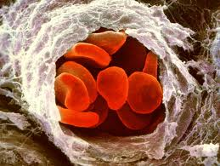
Capillary
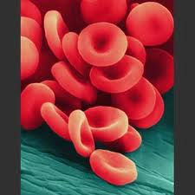
Red Blood Cells
- Gases
- Ions
- Waste materials

2. Red Blood Cells [erythrocytes]

- Made in red bone marrow
- Biconcave discs
- Survive 120 days
- Contain Haemoglobin [dark red] which picks up oxygen to form oxyhaemoglobin [bright red]. Carries O₂ from lungs to all parts of body. Oxygen set free when blood reaches a location where oxygen is needed.
- No nucleus and No mitochondria
- Transport CO₂ [20% of all CO₂ carried in red blood cells]
- Lack of iron leads to a lack of red blood cells which causes anaemia
- Destroyed in liver and spleen [form bilirubin and biliverdin which are bile pigments]
3. White Blood Cells

Functions produce antibodies and engulf cells (phagocytosis)
- Lymphocytes
  - T-cells attack cells infected by viruses or have turned cancerous
  - B-cells make antibodies that attack bacteria
- Monocytes
  - Engulf cells by phagocytosis
  - Present antigens to T-Cells so that they can respond to them
Produced in red bone marrow
Move in blood to all parts of the body
Some take up residence in organs e.g. liver, spleen, lymph nodes and tonsils

4. Platelets

- Cell fragments
- Involved in clotting
- Plug tears in blood vessels to prevent blood loss and entry of pathogens

Blood Groups

Based on surface chemistry of red blood cells i.e. antigens on cell surface
- A – antigen A on surface,
- B – antigen B on surface,
- AB – antigens A and B on surface, [universal recipient]
- O – no antigens on surface so not recognised as foreign [universal donor]

Rhesus⁺ and Rhesus–
- Rhesus⁺ has rhesus antigen on surface of red blood cells
- Rhesus⁻ has no rhesus antigen on surface of red blood cells
  - Rh⁻ mother can attack Rh⁺ baby in womb causing problems

Double Circulation
- Pulmonary circulation: heart → lungs → heart
- Systemic circulation: heart → body → heart

Heart Internal Structure and Blood Flow
Heart
- Located in thoracic cavity
- Strong double pump
- Made of special muscle
– does not tire
– branched
- Get oxygenated blood through coronary arteries
- Comes from aorta just after semi-lunar valves
- Blood returns through coronary veins

Hepatic Portal System
Carries glucose
N.B. The direction of blood flow in all three vessels
amino acids
minerals from intestine to liver

Cardiac Cycle

- Diastole the filling phase heart relaxed
- Systole the emptying phase muscles contracting
Sequence: heart relaxed / blood flows into atria from veins / bicuspid and tricuspid valves relax / blood flows into ventricles / atria contract pushing more blood into ventricles / ventricles contract / forces blood into arteries / bicuspid and tricuspid valves slam shut / “lub” sound / ventricles relax / blood tries to flow back from arteries into heart / semilunar valves slam shut / “dub” sound

Dissect, Display and Identify a Sheep’s Heart.

- Identify right and left – left side thicker or firmer [ pumps blood further]
- Place ventral side up
- On dissecting board
- Note coronary artery emerging from start of aorta and running over front of heart
- Using a scalpel
- Make cut from centre of left atrium to left ventricle – not on septum
- Repeat on right side
- Identify and flag label atria and ventricles, bicuspid and tricuspid valves
- Cut down pulmonary artery and aorta to show semi-lunar valves
- Safety precautions – wear rubber gloves and wash and sterilise equipment after use

Control of Heart Rate

Heart muscle beats by itself
Heart muscle is contractile i.e. it can shorten

Pacemakers

- Sinoatrial Node on the upper wall of right atrium
- Atrioventricular Node in the bottom of the right atrium near the septum.
- Average rate 75 beats per minute.
Rate affected by
- Nerve signals
- Hormones e.g. adrenalin released when one is excited or frightened speeds it up.

Pulse wave of pressure along arteries caused by ventricles contracting

Blood Pressure force exerted by blood on artery walls
- Highest at aorta as it leaves the heart and lowest at the right atrium.
- Measured on the upper arm

Action | Result
Smoking | High blood pressure, hardening of arteries, more risk of heart attack and stroke
Diet  High salt intake  Overeating | High blood pressure – danger of stroke  Blocked coronary arteries – heart attack
Exercise | Heart stronger, greater oxygen carrying capacity, lower resting heart rate

Investigate the Effect of Exercise on the Pulse [or Breathing Rate] of a Human.

- Record pulse at rest using first and second fingers on wrist [or breathing rate]
- Count number of pulse in 15 seconds and multiply by four to get rate per minute
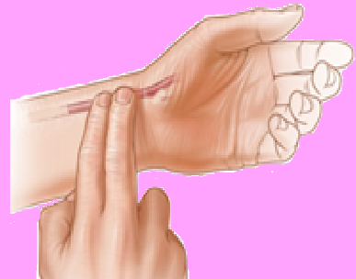Taking a Pulse
- Repeat 3 times – calculate average
- Do gentle exercise
- Calculate average heart rate as before
- Note time taken for pulse to return to resting rate
- Do vigorous exercise
- Calculate average heart rate as before
- Note time taken for pulse to return to resting rate
Results
- More strenuous exercise causes greater increase in heart rate.
- Fitter one is faster heart rate returns to normal and the slower resting heart rate is
- Similar results for breathing rate

Lymphatic System
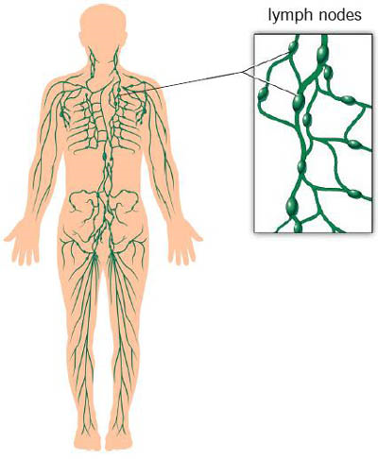
Lymphatic System
Lymph:
- All cells are bathed in tissue fluid which is plasma that has leaked from capillaries
- This flows into lymphatic capillaries and is called lymph, these capillaries merge to form lymph vessels.
- Along the lymph vessels there are swelling called lymph nodes which contain large numbers of phagocytic white blood cells that clean blood of debris, bacteria and cancer cells.
- Nodes are concentrated in neck, armpits and groin
- Vessels flow into the thoracic duct which drains into the blood at the subclavian vein
- One way flow – valves – muscle pressure moves lymph [similar to blood in veins]

Functions [any three]
Defence
- Nodes filter plasma removing pathogens and cell debris
- Produce lymphocytes [B and T cells]
- Lymphocytes produce antibodies

Transport
- Fats absorbed into the lacteals in villi
- Fats from lacteals taken by lymph and enter the blood at the subclavian vein
- Tissue fluid leaked from capillaries is returned into blood at subclavian vein
- Returns plasma proteins that have leaked from blood

Defence System

Pathogen Disease causing organism

Immunity Ability of body to defend itself from pathogens, cancer cells and toxins

General Defence System

- Targets any intruder harmful and beneficial

- Skin
- Physical barrier – dead cells on surface fall off
- Sweat and sebum contain antibacterial and antifungal chemicals
- Sebum keeps skin supple to prevent cracking
- Mutualistic bacterial prevent other micro-organisms getting a foothold

- Mucous Membranes

Lining cells that produce a sticky slime called mucus

Breathing System
- Mucus in breathing tract traps pathogens
- Cilia beat in unison to move mucus from lungs to throat where it is swallowed,
- Hairs in nose also trap pathogens and toxins
Reproductive System
- Mucus traps pathogens
- pH in vagina is acidic to kill bacteria and fungi
Digestive System
- Mucus lubricates the passage of food preventing damage and traps bacteria and fungi
- Hydrochloric acid in stomach kills bacteria
- Mutualistic bacteria in large intestine prevent pathogens establishing by outcompeting them.
- Phagocytic White Blood Cells [Monocytes]

- Roam at large and engulf large numbers of bacteria in an amoeba like fashion.
- Pus is a collection of (dead) phagocytic white blood cells.

Specific Defence System (Immune System)

- Targets particular pathogens or substances

Antigen: |  |  | a molecule (usually on cell surface) that stimulates the formation of antibodies.
Antibody |  |  | a protein made by lymphocytes in response to an antigen  They attach to the antigen and destroy the antigen or the cell to which it is attached
Induced Immunity |  |  | is the defence response involving the production of a specific antibody following the introduction and detection of an antigen.
Active Immunity |  |  | person produces their own antibodies in response to an antigen.  Memory cells give long lasting protection.
Passive Immunity |  |  | person does not produce their own antibodies but gets them from another source
- Natural - mother passes antibodies across the placenta and also in colostrum to her baby.
- Artificial - another animal makes the antibody and it is given to the patient e.g. horse and tetanus
Immunisation |  | medical protection against pathogens or toxins by vaccination or injection of antibodies
Vaccination |  | administration of a pathogen that is  - dead [whooping cough],  - weakened [rubella] or a  - harmless relative [cowpox for smallpox]  to produce antibodies and memory cells.

Role of Lymphocytes

- White blood cells made in foetal bone marrow.
- B cells mature in bone marrow and then enter the blood.
- Most of them take up residence in lymphoid tissue e.g. lymph nodes, spleen, tonsils and adenoids.
- T cells mature in the thymus

